Stelling Minnis CE Primary School

Relationships,

Sex and Health Education Policy

This policy is based on the Diocese of Canterbury’s guidance and principles.

Stelling Minnis Church of England Primary School is committed to offering a primary education of the highest quality to each child. The school deliberately sets out to create the right environment for all pupils, to allow them to develop in the way and at the pace appropriate to them. As a controlled Church of England School, we provide a secure, happy and stimulating learning environment where Christian faith leads our way. We aim to foster a true and lifelong desire to learn by presenting children with a wide and challenging curriculum set firmly within the guiding principles of Christian values, which we teach and model through all aspects of school life.

This policy should be read in the light of our Christian values of Love, Respect and Perseverance.

Ratified 19.3.2024

Reviewed Annually
1. Introduction
Legal Requirements
The statutory guidance from the Department for Education issued under Section 80A of the
Education Act 2002 and section 403 of the Education Act 1996.

The guidance will become compulsory in all schools from September 2020 and replaces the Sex
and Relationship guidance document published in 2000.

Schools must have regard to the guidance, and where they depart from those parts of the
guidance which state that they should (or should not) do something they will need to have good
reasons for doing so.

The Relationships Education and Health Education guidance document contains information on what schools should do and sets out the legal duties to which schools must comply when teaching Relationships Education, Relationships and Sex Education (RSE) and Health Education.
Under the proposals, all pupils will study compulsory health education as well as new reformed Relationships Education in primary school.
Withdrawal
Parents have the right to withdraw pupils from sex, but not relationships education. The national curriculum states that ‘all schools should make provision for personal, social, health and economic education (PSHE), drawing on good practice'. PSHE education contributes to schools' statutory duties outlined in the Education Act 2002 and the Academies Act 2010 to provide a balanced and broadly-based curriculum and is essential to Ofsted judgements in relation to personal development, behaviour, welfare and safeguarding.
The relationships and health aspects of PSHE will be the only part of the PSHE curriculum that will be compulsory in all schools (from 2020.)

Definition of Relationships Education.
Relationships education in primary school teaches children the fundamental building blocks and characteristics of positive relationships, with particular reference to friendships, family relationships, and relationships with other children and with adults.

Definition of Sex Education
Sex education is the informing of children about sexual issues, in a framework of morality and individual responsibility, and in a way that allows children to ask and explore moral questions.

Definition of Health Education
Health and mental wellbeing education in primary school focuses on teaching the characteristics of good physical health and mental wellbeing. It will provide a firm foundation to discuss the benefits of good health and wellbeing, enabling all to talk about the feelings and impact of poor health and wellbeing.
Christian Context
Relationships Education and RSE in schools with a religious character (para 19-22).
• All schools must have a good understanding of pupils’ faith backgrounds and form positive relationships between the school and local faith communities help to create a constructive context for the teaching of these subjects.
• In all schools, when teaching these subjects, the religious background of all pupils must be taken into account when planning teaching, so that the topics that are included in the core content in this guidance are appropriately handled. Schools must ensure they comply with the relevant provisions of the Equality Act 2010, under which religion or belief are amongst the protected characteristics
. • All schools may teach about faith perspectives. In particular, schools with a religious character may teach the distinctive faith perspective on relationships, and balanced debate may take place about issues that are seen as contentious. For example, the school may wish to reflect on faith teachings about certain topics as well as how their faith institutions may support people in matters of relationships and sex.
• In all schools, teaching should reflect the law (including the Equality Act 2010) as it applies to relationships, so that young people clearly understand what the law allows and does not allow, and the wider legal implications of decisions they may make.
Our context
For our school RSHE is taught within the Christian Context, Ethos and Values, relating specifically to our values of LOVE, RESPECT and PERSEVERANCE. To this end, RSE is taught in the light of the belief in the absolute worth of all people and the unconditional infinite love of God.
RSHE should be sensitive to the circumstances of all children and be mindful of the variety of expressions of family life in our culture, yet it should also uphold the Christian values regarding relationships and marriage as recognised by the Church of England (i.e. Marriage is a gift of God in creation and encompasses consent, public witness, permanence and lifelong fidelity)1
1 Please see Appendix 1 a, 1 b and 2

Aim of Relationships Education.
• To provide opportunities for children to learn about securing, developing and sustaining healthy relationships and knowing to deal with recognise when and how relationships go wrong.
• To prepare children for the opportunities, joys, challenges and responsibilities of being in relationship with other people.
• To provide the understanding, vocabulary and strategies children need to keep themselves safe and to thrive within good relationships of all kinds.
• To give children accurate information to equip them for life in the modern world and make sure they are not harmed or negatively influenced by unrealistic or dangerous materials and expectations.
DfE Guidance on Sex Education curriculum:
It will be for primary schools to determine whether they need to cover any additional content on sex education to meet the needs of their pupils.
It is important that the transition phase before moving to secondary school supports pupils’ ongoing emotional and physical development effectively. The Department continues to recommend therefore that all primary schools should have a sex education programme tailored to the age and the physical and emotional maturity of the pupils. It should ensure that both boys and girls are prepared for the changes that adolescence brings and – drawing on knowledge of the human life cycle set out in the national curriculum for science - how a baby is conceived and born.
Meeting these objectives will require a graduated, age-appropriate programme of sex education. Teaching needs to take account of the developmental differences of children.

Aim of Sex Education
The diocese encourage all schools to approach Sex Education in a faith sensitive and inclusive way. Such an approach should seek to understand and appreciate differences within and across the teachings of the Christian faith and other communities the school serves.

Aim of Physical health and mental wellbeing education
• To teach the characteristics of good physical health and mental wellbeing and that they are interlinked i.e.: good physical health contributes to good mental health and vice versa.
• To highlight the importance of mental wellbeing being part of normal daily life, in the same way as physical health.
• To promote pupils’ self-control and ability to self-regulate, and provide strategies for doing so.
• To reduce stigma attached to health issues, in particular those to do with mental wellbeing.
• To engender an atmosphere that encourages openness, so pupils feel they can check their understanding and seek any necessary help and advice as they gain knowledge about how to promote good health and wellbeing.
Key Learning Objectives
Effective relationships education lessons will:
Ø Talk explicitly about the features of healthy friendships, family relationships and other relationships which young children are likely to encounter.
Ø Draw attention to a range of contexts enabling pupils to form a strong early understanding of the features of relationships that are likely to lead to happiness and security, helping them to recognise any less positive relationships when they encounter them.
Ø Create opportunities for pupils to be taught about positive emotional and mental wellbeing, including how friendships can support mental wellbeing.
Ø Be delivered in a sensitive and well-judged way based on knowledge of pupils and their circumstances, when teaching about families and relationships. Lessons will acknowledge that families of many forms provide a nurturing environment for children, so care needs to be taken to ensure that there is no stigmatisation of children based on their home circumstances and needs, to reflect sensitively that some children may have a different structure of support around them; e.g. looked after children or young carers.
Ø Be taught in a graduated, age-appropriate programme of Relationships Education, as children of the same age may be developmentally at different stages, leading to differing types of questions or behaviours. Teaching methods should take account of these differences (including when they are due to specific special educational needs or disabilities) and the potential for discussion on a one-to-one basis or in small groups.
Relationships Education curriculum will cover these areas through graduated age appropriate activities and discussions. (page 20-22)
Families and people who care for me
• Caring friendships
• Respectful relationship
• Online relationships
• Being safe

Effective physical health and mental wellbeing lessons will:
Ø Teach the benefits and importance of daily exercise, good nutrition and sufficient sleep.
Ø Give pupils the language and knowledge to understand the normal range of emotions that everyone experiences.
Ø Enable pupils to articulate how they are feeling, develop the language to talk about their bodies, health and emotions.
Ø Provide discussion and reflection opportunities for pupils to judge whether what they are feeling and behaving is appropriate and proportionate for the situations that they experience.
Ø Talk about the steps pupils can take to protect and support their own and others’ health and wellbeing, including simple self-care techniques, personal hygiene, prevention of health and wellbeing problems and basic first aid.
Ø Emphasise the positive two-way relationship between good physical health and good mental wellbeing, and the benefits to mental wellbeing of physical exercise and time spent outdoors.
Ø Teach and discuss the benefits of hobbies, interests and participation in their own communities, making it clear that people are social beings and that spending time with others, taking opportunities to consider the needs of others and practising service to others, including in organised and structured activities and groups (for example the scouts or girl guide movements), are beneficial for health and wellbeing.
Ø Teach and discuss the benefits of rationing time spent online and the risks of excessive use of electronic devices.
Ø Teach and discuss why social media, computer games and online gaming have age restrictions and should be equipped to manage common difficulties encountered online.
Ø Create a firm foundation where pupils are aware of the benefits and characteristics of good health and wellbeing.
Ø Enable teachers to talk about isolation, loneliness, unhappiness, bullying and the negative impact of poor health and wellbeing. Health and mental wellbeing curriculum will cover these areas through age appropriate activities and discussions. (page 32 – 35)
• Mental wellbeing
• Internet safety and harms
• Physical health and fitness
• Healthy eating
• Drugs, alcohol and tobacco
• Basic first aid
• Changing adolescent body

Content and Organisation
Our RSHE is delivered through the programme Jigsaw. This gives clear continuity and progression throughout the school and covers all the required and statutory areas of the curriculum. This is taught within our PSHE lessons.
The curriculum is divided into 6 termly topics.
Being Me in my World
Celebrating Difference
Dreams and Goals
Healthy Me
Relationships
Changing Me

PSHE Curriculum Overview

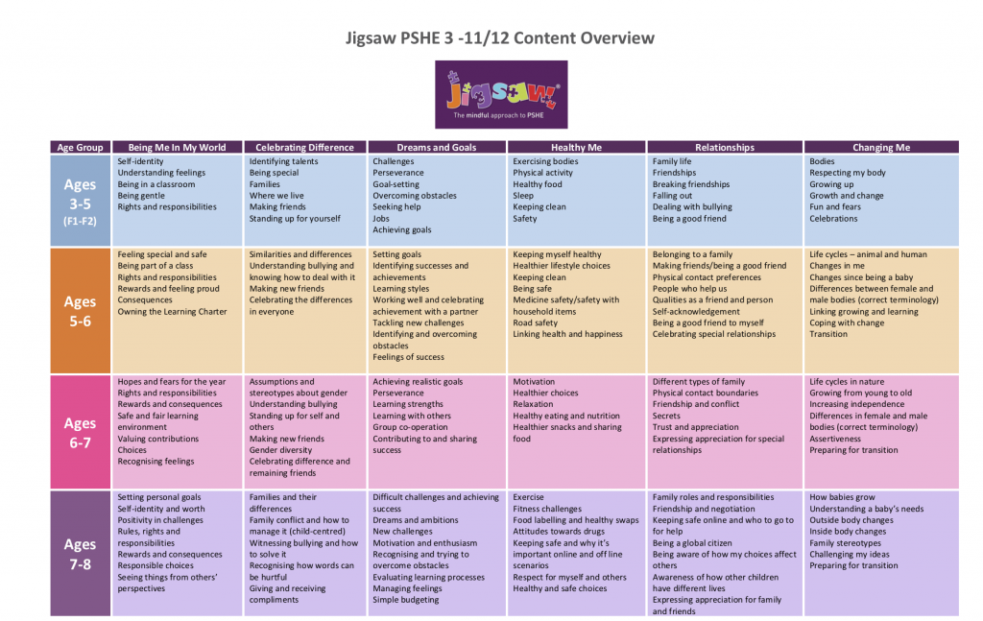
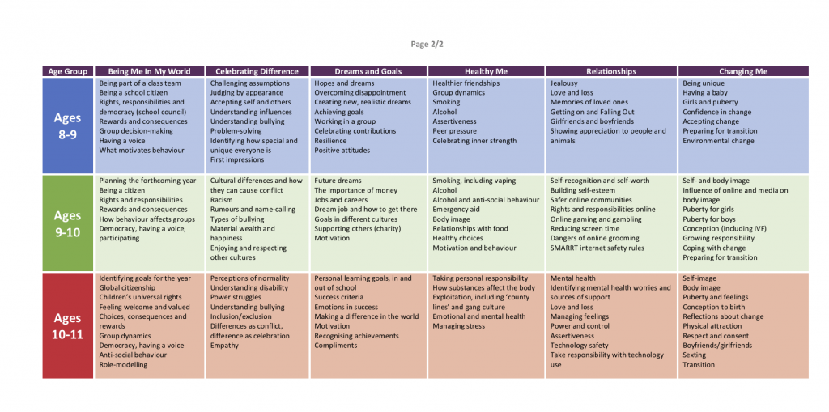

Leading of the subject
The teaching will be led by the PSHE subject leaders, who will monitor and evaluate the teaching of the subject.
This policy has been created by the school and is available for review and discussion by the parents on the school’s website. Is to be reviewed and updated annually by the governing body.
Equal Opportunities
This teaching will be delivered in line with the school’s equal opportunities policy within an atmosphere of mutual respect. Resources selected to support the programme will be free from cultural bias wherever possible and will avoid gender stereotyping. SRHE will be available to all pupils regardless of gender, culture or disability.
Other Issues
Personal Beliefs
Beliefs and attitudes of teachers should not influence their teaching of SRHE.
Language and Ground Rules in RSHE lessons
- No one will feel forced to answer a personal question
- No one will be forced to take part in discussions
- Language used should be easily understood by all
- Correct names for body parts will be used
- Meanings of words will be explained in a simple, factual way

Useful Documents and Resources
Key references can be found below:
DfE Guidance on Relationships Education and Health and Wellbeing Education.
Relationships Education, Sex Education and Health and Mental Wellbeing guidance for Church of England Primary Schools in Canterbury Diocese.

Appendices - Preface and Declarations
Appendix 1a
Common Worship Marriage Preface
In the presence of God, Father, Son and Holy Spirit,
we have come together
to witness the marriage of N and N, Public Witness
to pray for God's blessing on them,
to share their joy
and to celebrate their love.
Marriage is a gift of God in creation
through which husband and wife may know the grace of God.
It is given
that as man and woman grow together in love and trust,
they shall be united with one another in heart, body and mind,
as Christ is united with his bride, the Church.
The gift of marriage brings husband and wife together
in the delight and tenderness of sexual union Sexual Union
and joyful commitment to the end of their lives. Permanence
It is given as the foundation of family life
in which children are [born and] nurtured
and in which each member of the family in good times and in bad,
may find strength, companionship and comfort,
and grow to maturity in love.
Marriage is a way of life made holy by God,
and blessed by the presence of our Lord Jesus Christ
with those celebrating a wedding at Cana in Galilee.
Marriage is a sign of unity and loyalty
which all should uphold and honour.
It enriches society and strengthens community.
No one should enter into it lightly or selfishly
but reverently and responsibly in the sight of almighty God.
N and N are now to enter this way of life.
They will each give their consent to the other Consent
and make solemn vows,
and in token of this they will [each] give and receive a ring.
We pray with them that the Holy Spirit will guide
and strengthen them,
that they may fulfil God's purposes
for the whole of their earthly life together. Permanence
Appendix 1b
Common Worship Declarations
The minister says to the bridegroom
N, will you take N to be your wife? Consent
Will you love her, comfort her, honour and protect her,
and, forsaking all others,
be faithful to her as long as you both shall live? Permanence
He answers
I will.
The minister says to the bride
N, will you take N to be your husband? Consent
Will you love him, comfort him, honour and protect him,
and, forsaking all others,
be faithful to her as long as you both shall live? Permanence
She answers I will.
Appendix 2
Characteristics of Marriage
Cornes, identifies four elements that constitute marriage.4
4 Cornes (2002, p.39).
5 Wenham & Heth (2002, p.103
6 Common Worship: Pastoral Services (2005, p.105
7 Cornes (2002, p.41).
8 Common Worship: Pastoral Services (2005, pp.105-6
9 Stott (1984, p.259).
10 Book of Common Prayer, Marriage Service
1) Consent. Both parties must express the intention and willingness to enter
into a binding marital union (Gen 24:5-8,57). It is a ‘leaving’ of parents and a ‘cleaving’ to the new spouse (Gen 2:24).
2) Permanence. ‘Marriage in the Bible is first and foremost a binding covenant’.5 The Lord will not release a person from vows (Num 30), even vows made rashly (Ecc 5:4-7). Therefore marriage should not be entered into ‘lightly or selfishly but reverently and responsibly’.6 The marriage ordinance also implies exclusivity (a man… his wife) and the ‘exclusive nature of marriage is affirmed in the NT’.7
3) Public Witness. Although, in the Old Testament, marriage was a family rather than ‘priestly’ matter, both family and public witness were and remain important constituents of this new social relationship (Gen 34:11ff; Deut 22:13-19).
4) Sexual Union. The ‘one-flesh union’ clearly refers to the bodily union of man and wife (Gen 2:24), male and female with the possibility of pro- creation. However, sexual intercourse does not, of itself, create a marriage bond, since marriage is still required after intercourse (Ex 22:16). This aspect of marriage is why it is prohibited between men and women within a certain degree of affinity – e.g. brother and sister, mother and son.
All four of these elements are reflected in the Preface and Declarations of the Marriage Service which also makes clear the purposes for which God ordained marriage, namely, procreation (Gen 1:28), mutual help/comfort (Gen 2:18) and the reciprocal commitment of self-giving love which finds its expression in sexual union (Gen 2:24).8 Stott notes that all three needs have been strengthened by the Fall.9 Finally, because it is a creation ordinance, ‘instituted by God himself in the time of man’s innocency’ it is given to all humanity.10
Divorce and subsequent remarriage whilst a previous partner is still living is a complex and sensitive issue. The decision not only affects the couple but also the wider community. It is permitted by the Church of England, but Bishops' Guidelines must be followed and ultimately the decision is left to the conscience and judgement of the individual minister. Similarly, issues of gender reassignment are pastorally sensitive. Church of England ministers are permitted to marry those who have had gender legally reassigned but they can also exercise a conscientious objection not to do so.
References
Common Worship: Pastoral Services (2005),2nd edn, Church House Publishing, London. Page 9 of 10
Cornes, A.(2002),Divorce and Remarriage,1st edn, Christian Focus Publications, Scotland.
Stott, J.(1984),Issues Facing Christians Today 1stedn,Marshall, Morgan & Scott, Basingstoke.
Wenham,G.J.&Heth, W.E.(2002), Jesus and Divorce, 2nd edn, Paternoster Press, Carlisle.

Appendix 3
Aspects of Love
C. S. Lewis in his book, The Four Loves (1960) using four Greek words for love, describes four basic kinds of human love – affection (storge), friendship (philia), erotic (eros) love and the love of God (agape). Lewis states that just as Lucifer a former archangel – perverted himself by pride and fell into depravity, so too can love – commonly held to be the arch-emotion – become corrupt by presuming itself to be what it is not.
Affection,– defined as ‘affection especially of parents to offspring’. It is described as a humble quiet love, found between those who are ‘thrown together’ by circumstance. It is the most natural love because it is present without coercion and is the result of fondness by virtue of familiarity. It pays least attention to those attributes that are often deemed valuable, e.g. physical beauty or giftedness, and is therefore able to transcend most discriminating factors.
The word is not used in Scripture although there are many examples of it, e.g. the command to ‘honour father and mother’. The negative form is used twice
Romans 1:31 – they have no understanding, no fidelity, no love, no mercy.
2 Timothy 3:3 – without love, unforgiving, slanderous, without self-control, brutal, not lovers of the good,
Romans 12:20 uses a compound of phileo and storge.
Friendship – This is the love of friendship, best friends, and the fellowship of being with those people you enjoy usually because of shared interests or activities. It was exalted as a virtue in ancient cultures whereas contemporary society rather ignores it. Lewis recognises that it is not a ‘biological love’. By contrast, without erotic love we would not have been begotten, without affection we would not have been reared, whereas we can live and breed without friendship. Friendship is ‘a relation between men at their highest level of individuality’.
John 21:15-17, describes Jesus' restoral of Peter, where the different words used seem to convey some import:
Jesus asked, ‘do you agapao me?’
Peter replied, ‘I phileo you.’
Jesus asked, ‘do you agapao me?’
Peter replied, ‘I phileo you.’
Jesus asked, ‘do you phileo me?’
Peter replied, ‘I phileo you.’
We are not commanded to phileo anyone because this form of love depends on feelings. Examples of use are: John 5:20, 11:3, 36, 12:25, 16:27, 20:2; Ac 28:2; Ro 12:10; 1Ti 6:10; 2Ti 3:4; Tit 2:4, 3:4; Heb 13:1; 3Jo 9; and Re 3:19. Page 10 of 10
Eros – This type of love covers everything from queasy stomachs and warm fuzzy feelings to strong sensual passion. It can be selfish – one person ‘wants’ another’ (cf. Marriage Service, ‘all that I am I give to you’, i.e. reciprocated, consensual yielding of oneself to another). In order to exist eros is dependent upon the situation and circumstances. It is also held captive to each person's perception. For example, if someone perceives a particular quiet evening dinner with candles to be romantic, eros will thrive. However, passion becomes squashed for someone whenever he or she interprets the current situation to be undesirable. Eros thus grows strong and then wastes away based upon our perceptions. Whilst the word does not appear in Scripture, the Song of Solomon is a highly passionate love poem expressing erotic love between a man and a woman.
Agape - The Greek word that refers to the love of God, one of the kinds of love we are to have for people, is agape. Lewis recognises it as the highest form of love and a specifically Christian virtue. Agape is the very nature of God, for God is love (1 John 4:7-12, 16b). The big key to understanding agape is to realize that it can be known from the action it prompts. People today are accustomed to thinking of love as a feeling, but that is not necessarily the case with agape love. Agape is love because of what it does, not because of how it feels.
God so ‘loved’ (agape) that He gave His Son. It did not feel good to God to do that, but it was the loving thing to do. Christ so loved (agape) that he gave his life. He did not want to die, but he loved, so he did what God required. A mother who loves a sick baby will stay up all night long caring for it, which is not something she wants to do, but is a true act of agape love.
The point is that agape love is not simply an impulse generated from feelings. Rather, agape love is an exercise of the will, a deliberate choice. This is why God can command us to love our enemies (Matt. 5:44; Exod. 23:1-5). The Marriage Service does not ask ‘Do you love’ (present), but ‘Will you love’ (future), Future feelings cannot be predicted but a commitment can be made to future actions.
Love is the distinctive character of the Christian life in relation to other Christians and to all humanity. The ‘loving’ thing to do may not always be easy, and true love is not ‘mushy sentimentalism.’ There is often a cost to genuine love.

