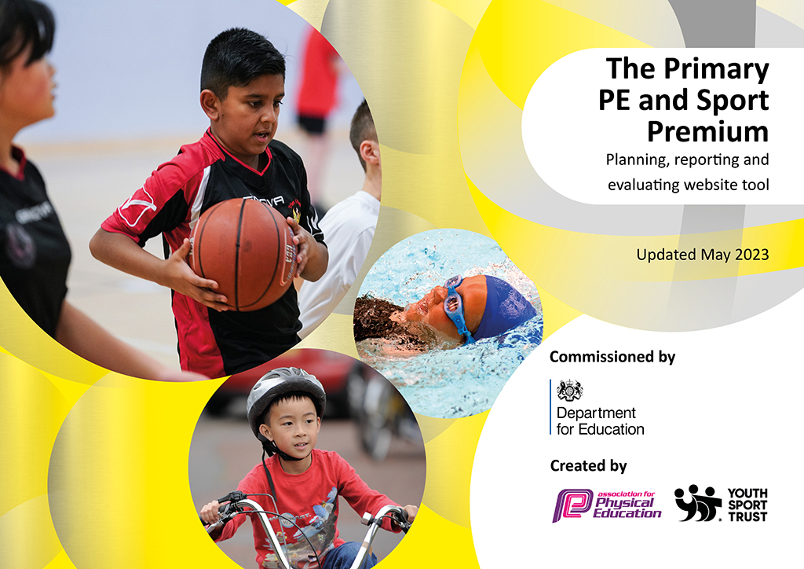
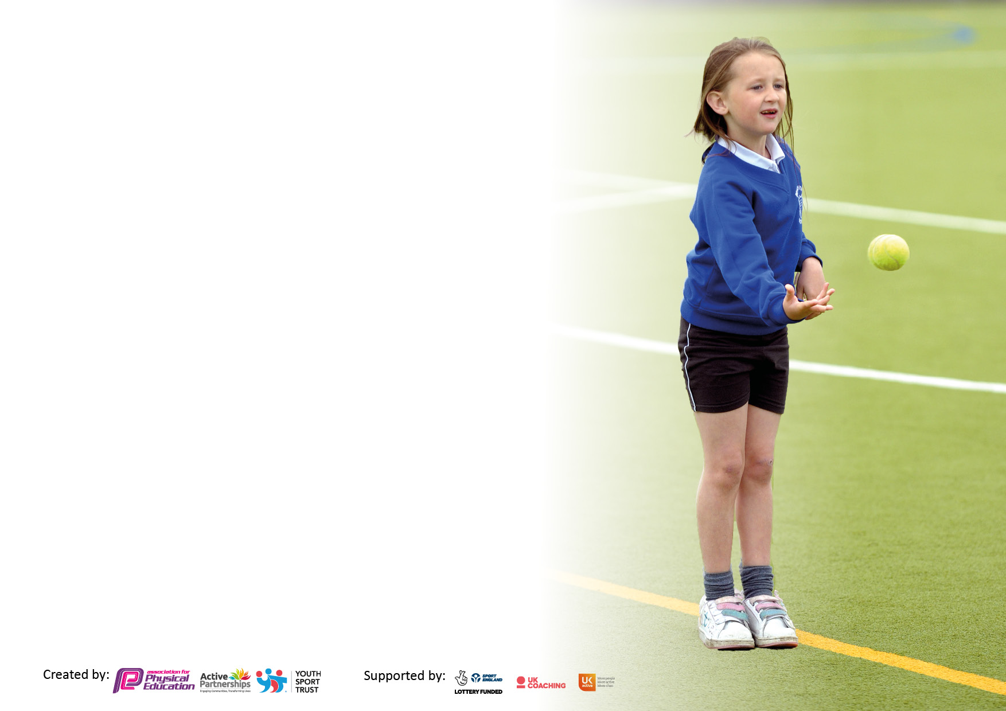

It is important that your grant is used effectively and based on school need. The Education Inspection Framework makes clear there will be a focus on ‘whether leaders and those responsible for governors all understand their respective roles and perform these in a way that enhances the effectiveness of the school’.

Under the Quality of Education judgement, Ofsted inspectors consider:
Intent - Curriculum design, coverage and appropriateness
Implementation - Curriculum delivery, teaching (pedagogy) and assessment
Impact - Attainment and progress

To assist schools with common transferable language, this template has been developed to utilise the same three headings which should make your plans easily transferable between working documents.

Schools must use the funding to make additional and sustainable improvements to the quality of Physical Education, School Sport and Physical Activity (PESSPA) they offer. This means that you should use the Primary PE and sport premium to:

- Develop or add to the PESSPA activities that your school already offers
- Build capacity and capability within the school to ensure that improvements made now will benefit pupils joining the school in future years
- The Primary PE and sport premium should not be used to fund capital spend projects; the school’s budget should fund these.

Please visit https://www.gov.uk/guidance/pe-and-sport-premium-for-primary-schools for the revised DfE guidance, including the 5 key indicators across which schools should demonstrate an improvement. This document will help you to review your provision and to report your spend. DfE encourages schools to use this template as an effective way of meeting the reporting requirements of the Primary PE and Sport Premium.

We recommend you start by reflecting on the impact of current provision and reviewing the previous spend.

Schools are required to publish details of how they spend this funding, including any underspend from 2021/2022, as well as on the impact it has on pupils’ PE and sport participation and attainment.

We recommend regularly updating the table and publishing it on your website throughout the year. This evidences your ongoing self-evaluation of how you are using the funding to secure maximum, sustainable impact. Final copy must be posted on your website by the end of the academic year and no later than the 31 July 2023.

Details with regard to funding
Please complete the table below.

Total amount carried over from 2021/22 | £0
Total amount allocated for 2022/23 | £16,700
How much (if any) do you intend to carry over from this total fund into 2023/24? | £0
Total amount allocated for 2023/24 | £
Total amount of funding for 2023/24 to be reported on by 31st July 2024 | £
Swimming Data
Please report on your Swimming Data below.

Meeting national curriculum requirements for swimming and water safety.

N.B. Complete this section as best you can. For example, you might have practised safe self-rescue techniques on dry land which you can then transfer to the pool when school swimming restarts.
Due to exceptional circumstances priority should be given to ensuring that pupils can perform safe self-rescue even if they do not fully meet the first two requirements of the NC programme of study
What percentage of your current Year 6 cohort swim competently, confidently and proficiently over a distance of at least 25 metres?  N.B. Even though your pupils may swim in another year, please report on their attainment on leaving primary school at the end of the summer term 2023.  Please see note above | %100
What percentage of your current Year 6 cohort use a range of strokes effectively [for example, front crawl, backstroke and breaststroke]?  Please see note above | %83
What percentage of your current Year 6 cohort perform safe self-rescue in different water-based situations? | %100
Schools can choose to use the Primary PE and sport premium to provide additional provision for swimming, but this must be for activity over and above the national curriculum requirements. Have you used it in this way? | No

Action Plan and Budget Tracking
Capture your intended annual spend against the 5 key indicators. Clarify the success criteria and evidence of impact that you intend to measure to evaluate for pupils today and for the future.

Academic Year: 2022/3 | Total fund allocated: | Date Updated:
Key indicator 1: Increase confidence, knowledge and skills of all staff in teaching PE and sport |  |  |  | Percentage of total allocation:
 |  |  |  | %
Intent | Implementation |  | Impact
Your school focus should be clear on what you want the pupils to know and be able to do. What do they need to learn and to consolidate through practice: | Make sure your actions to achieve are linked to your intentions: | Funding allocated: | Evidence of impact:  What do pupils now know and what can they now do? What has changed? | Sustainability and suggested next steps:
Employ a specialist teacher to model good practice and upskill staff.  Teaching assistants are upskilled to support individual pupils with PE activities and individual physio programmes including sensory circuits. | Specialist teacher employed one day per week to model and upskill staff.  Swimming teacher sent on update course.  Children with additional needs have full access to PE in school as well as targeted interventions. | £7,317.50 | Children have benefitted form confident staff offering a wider range of activities.  Children with additional needs are fully supported and access suitable interventions as well.
Key indicator 2: The engagement of all pupils in regular physical activity – Chief Medical Officers’ guidelines recommend that  primary school pupils undertake at least 30 minutes of physical activity a day in school |  |  |  | Percentage of total allocation:
 |  |  |  | %
Intent | Implementation |  | Impact
Your school focus should be clear on what you want the pupils to know and be able to do. What do they need to learn and to consolidate through practice: | Make sure your actions to achieve are linked to your intentions: | Funding allocated: | Evidence of impact:  What do pupils now know and what can they now do? What has changed? | Sustainability and suggested next steps:
Children are offered 2 hours of PE each week to develop skills and promote good health through exercise.  The subject lead has knowledge and skills to support staff.  Wider opportunities are offered to promote interest of all students including after school clubs and competitions.  Forest School sessions run weekly  Swimming lessons are provided for Year 3 and Year 6 children. | Specialist PE teacher employed to model high quality teaching to staff. All children access 2 hours of PE e ach week as well as opportunities to learn new skills and take part in competitions.  All children have access to Forest School sessions each term on a rota basis. EYFS have sessions every week. | £13342.33 | All children Have benefitted from at least 2 hours of physical activity each week in addition to lunch and play breaks. Children enjoy Forest School and love to take part in competitions within school and across local schools.

Key indicator 3: The profile of PE and sport is raised across the school as a tool for whole school improvement |  |  |  | Percentage of total allocation:
 |  |  |  | %
Intent | Implementation |  | Impact
Your school focus should be clear on what you want the pupils to know and be able to do. What do they need to learn and to consolidate through practice: | Make sure your actions to achieve are linked to your intentions: | Funding allocated: | Evidence of impact:  What do pupils now know and what can they now do? What has  changed? | Sustainability and suggested next steps:
The school is committed to raising the profile of physical activity in school through sports and other outdoor learning. The support of Shepway sports would be invaluable in this objective.  We would continue to explore further opportunities to develop skills and confidence in the extended day. | School subscribes to Shepway sports package. | £4,150.00 | Children enjoy a range of activities which may not be included in the school curriculum offer.
Key indicator 4: Broader experience of a range of sports and physical activities offered to all pupils |  |  |  | Percentage of total allocation:
Intent | Implementation |  | Impact
Your school focus should be clear on what you want the pupils to know and be able to do. What do they need to learn and to consolidate through practice: | Make sure your actions to achieve are linked to your intentions: | Funding allocated: | Evidence of impact:  What do pupils now know and what can they now do? What has  changed? | Sustainability and suggested next steps:
We would continue to explore further opportunities to develop skills and confidence in the extended day. | School employs coaches in dance, rugby and basketball.  School organizes Year 6 trip to Hindleap outdoor education centre contributing to cost and coaches to make it accessible to all. | £1131.95 | Extra activities are enjoyed by many children after school.  Year 6 benefit from a residential trip which encompasses activities such as canoeing, climbing, zipwire etc.

Key indicator 5: Increased participation in competitive sport |  |  |  | Percentage of total allocation:
 |  |  |  | %
Intent | Implementation |  | Impact
Your school focus should be clear on what you want the pupils to know and be able to do. What do they need to learn and to consolidate through practice: | Make sure your actions to achieve are linked to your intentions: | Funding allocated: | Evidence of impact:  What do pupils now know and what can they now do? What has  changed? | Sustainability and suggested next steps:
Subscription to Shepway Sports package  Competitions with local small schools  District Sports  Provide transport as needed to attend activities. | Children accessed competitions such as athletics with other schools. They played hockey and netball. They had a football tournament with local schools. | £949

Signed off by
Head Teacher: | Julie Simmons
Date: | 25th July 2023
Subject Leader: | Beth Alexander
Date: | 25th July 2023
Governor: | Pam Burgess
Date: | 25th July 2023

